4-1 Activity: Exceptions

Patrick Harrington
Bachelor of Science in Computer Science, SNHU
CS 405: Secure Coding
Instructor: Aaron Demory
May 28, 2026

Exceptions Static Testing Summary
Application Console Output
The completed C++ program was compiled and executed from Visual Studio Code on macOS using g++ with the C++17 standard. The screenshot below shows the application handling the divide-by-zero error, nested standard exception, and custom application exception without crashing.
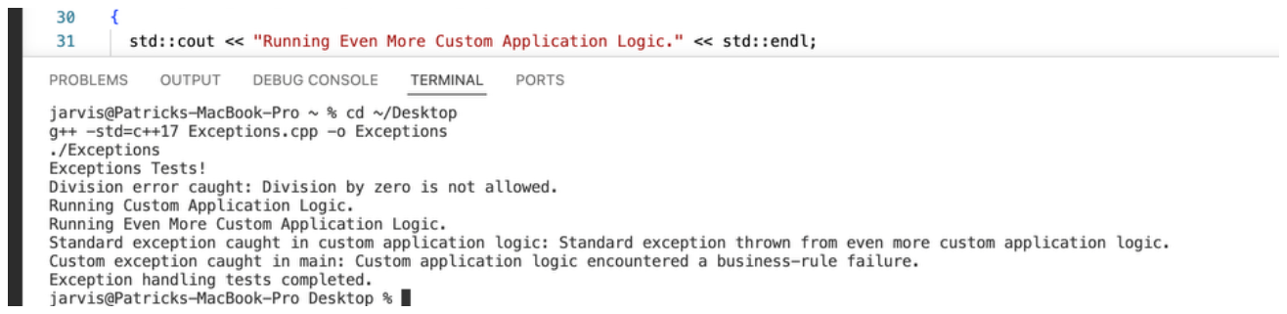
Console Output Text
Exceptions Tests!
Division error caught: Division by zero is not allowed.
Running Custom Application Logic.
Running Even More Custom Application Logic.
Standard exception caught in custom application logic: Standard exception thrown from even more custom application logic.
Custom exception caught in main: Custom application logic encountered a business-rule
failure.
Exception handling tests completed.

Summary of Process
I reviewed the provided starter code and identified each TODO related to exception handling. The main issues were that risky operations were not protected by try-blocks, divide-by-zero was not handled, and the application did not yet include a custom exception type for application-specific failures. I implemented a custom exception class derived from std::exception, overrode the what() method, and used a stored message string so the handler could display meaningful information to the user.
Next, I updated the nested application logic to throw a standard std::runtime_error and wrapped that call in a try/catch block that catches std::exception by const reference. This allowed the program to display the exception message and continue processing instead of terminating unexpectedly. For the division function, I added a denominator check and threw std::invalid_argument when division by zero was detected. Because do_division() is marked noexcept, the invalid_argument exception is caught inside that function so it does not escape and cause termination.
Finally, I wrapped the main program workflow in exception handlers ordered from most specific to most general: the custom exception, std::exception, and then a catch-all handler. The catch-all handler is useful as a final safety net because it can prevent abrupt termination from unexpected exceptions, but it should not be the primary error-handling strategy. It is generally a last resort because it does not provide type-specific details or a what() message. Specific exception handlers are better for debugging, maintainability, and giving users accurate error messages.
Issues Encountered and Resolutions
Divide-by-zero risk: Resolved by checking the denominator and throwing std::invalid_argument before division occurs.
Nested standard exception: Resolved by wrapping the call to do_even_more_custom_application_logic() in a try-block and catching std::exception.
Application-specific failure: Resolved by creating CustomApplicationException derived from std::exception and catching it explicitly in main().
Unexpected termination risk: Resolved by adding a main-level catch-all handler after the specific handlers.
User-facing output: Resolved by printing clear messages and exception.what() text whenever an exception with a standard interface is caught.
Best Practices Demonstrated
- Exceptions are derived from std::exception instead of throwing non-standard types.
- Exception handlers catch by const reference to avoid unnecessary copying and preserve polymorphic behavior.
- Handlers are ordered from specific to general so the most meaningful handler runs first.
- Inline comments explain the purpose of each exception-related change.
- The program displays clear messages rather than crashing without explanation

